Computer Vision and Image Processing: Homework 3

Homography and fundamental matrix estimation

**Name**: Manpreet Dhanjal

**UBIT Name**: DHANJAL

**Person Number**: 50248990

# Introduction:

Homography matrix defines the relationship between the pixels of two images which have been produced by the same camera or different cameras, centered at the same location. The camera might be rotated at any angle to take the different images. The homography matrix defines the transformation that the pixels in one image has to go through to reach the pixel in second image.

Similarly, fundamental matrix defines the relationship between the pixels of two images taken from different places, hence it involves the rotation, translation etc.

# Analysis & Results:

## Homography Estimation:

* **Detect Features**

In order to estimate the homography matrix, we need matching features in the two images. The features can be calculated using corner detector, blob detector or SIFT detector. The blobs detect scale invariant features whereas SIFT gives scale as well as direction invariant features. When using corner detector, we need to pick the neighborhood pixels of the corner to form a feature. This will result in better matching results. I have used Harris corner detector with sigma=1, radius=1 and threshold=0.01 to detect corners in both of the images and formed the feature using 18x18 neighborhood.

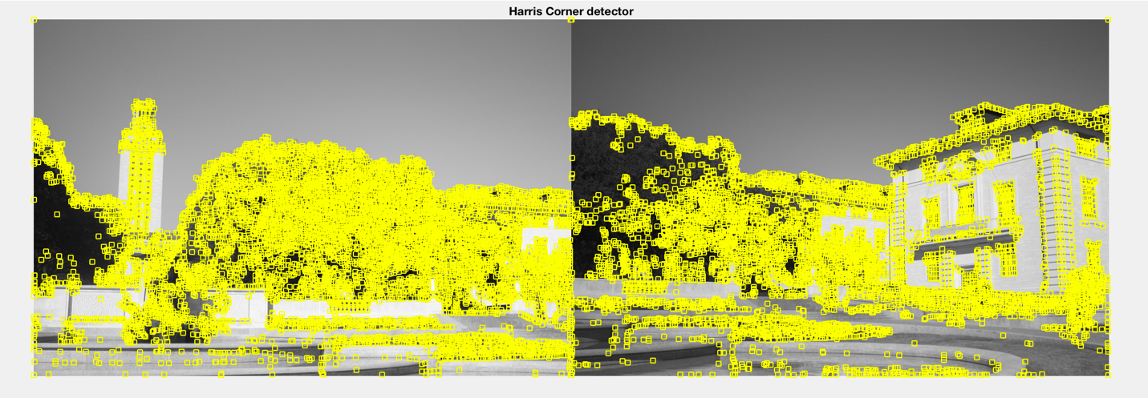

Figure: Corners detected using Harris Detector

* **Finding putative matches**

Once the features have been extracted, we need to find the distance between each feature and save the features which have the minimum distance between them.

I have used dist2 function to find the closest matching features in both images. I have sorted the distance matrix and picked the top 200 matches from that as the matching features.

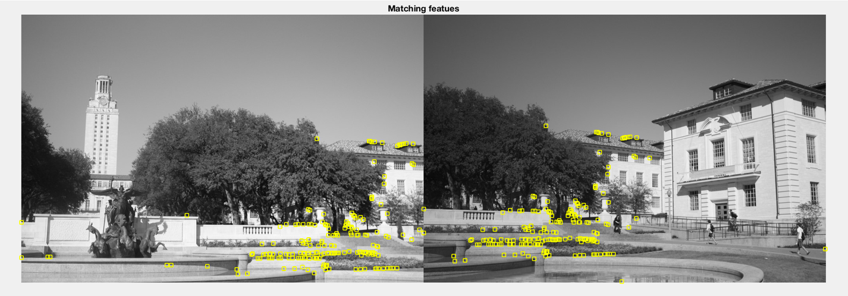

Figure: Putative Matches

* **RANSAC**

The matching features obtained from the above step are used to calculate the homography matrix. The homography matrix can be estimated using 4 matching points from each image using the following formula:

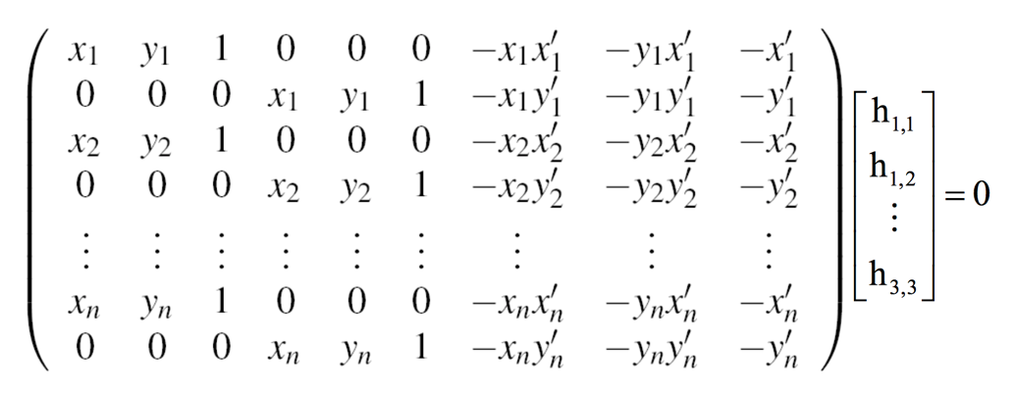

Figure: Calculate homography matrix

Here, (x1,y1 – xn,yn) are the points in the first image and (x1’,y1’ – xn’,yn’) are the points in the second image. The points (h11 to h33) are the points of the homography matrix. Creating the above matrix (say A) using 4 random matching points from both image and calling svd on it results in the homography matrix points if we pick the eigen vector of the minimum eigen value of A’A.

The above process is repeated a number of times and the best configuration is saved. The best configuration is obtained by picking the matrix that gives the maximum ratio of inliers with the total matches.

Inliers are the points that are correctly transformed by the homography matrix within some margin and all other points are outliers.

We finally reshape the points obtained into a 3x3 matrix and use it to transform the first image into the second image.

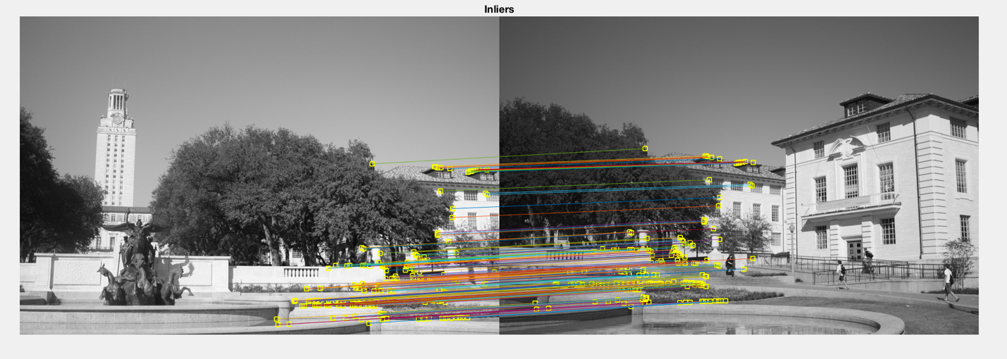

Figure: Inliers

Inlier Count : 174

Ratio : 0.8700

Average Residual : 1.2414

* **Align and blend image**

Finally, a composite image containing both the images is created. In order to get the size of the composite image, I calculate the transformation of the corners of the first image. This gives me the total length and breadth of the composite image. By subtracting the total length and breadth of the image with the size of the transformed image, I get the offset on the x and y axis for the transformed image.

I create 2 images, left and right half of the composite image and combine them using the add operation and average the overlapping area. The right half is created using interpolation of the pixels onto a grid of the size of composite image and the left half is created by putting the transformed image in a grid as big as the composite image using the x and y offsets.

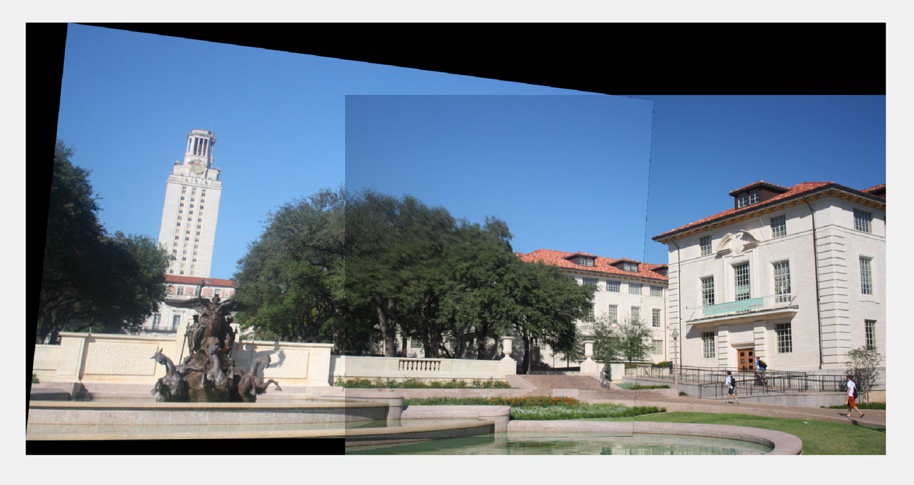

Figure: Aligned and Blended Image

# Fundamental Matrix Estimation:

There are 2 algorithms for the fundamental matrix estimation, one uses normalized features and the other uses unnormalized features. The fundamental matrix is defined as:

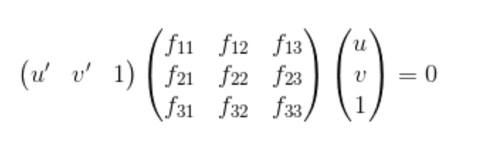

which can also be written as



In order to calculate fundamental matrix, we need 8 matching points and put it in the above formula. We calculate a matrix A, by stacking the 8 points from both images and taking svd and getting the eigen vector for A’A with the minimum eigen value.

**Using un-normalized algorithm with ground truth matches:**

Here the matches are directly used for the calculation of fundamental matrix. However, due to noise in the image and other factors, this estimation doesn’t always result in accurate matrix.

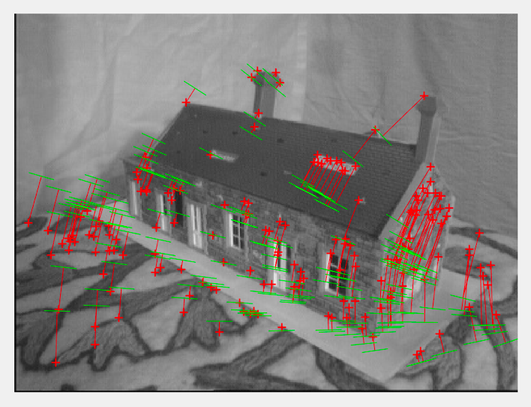 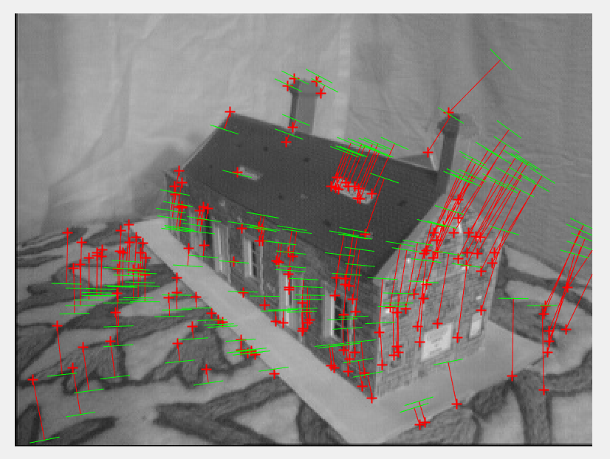

Figure: Unnormalised algorithm with ground truth matches

Average Residual for image 1: 696.8593

Average Residual for image 2: 1.1003e+03

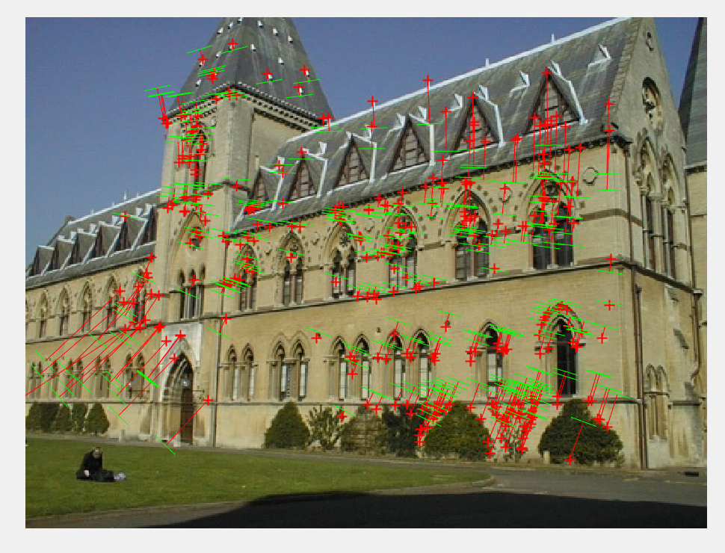 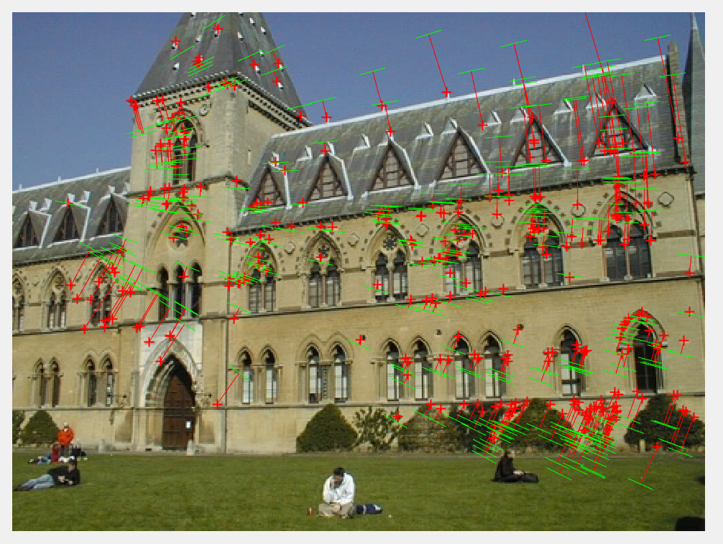

Figure: Unnormalised algorithm with ground truth matches

Average Residual for image 1: 469.7173

Average Residual for image 2: 503.5755

**Using normalized algorithm with ground truth matches:**

Because of the inaccuracies of the un normalized method, we obtain the fundamental matrix using the normalized matches, that is, we calculate the mean value of the x and y coordinates and subtract it from all the coordinates and then divide it by the standard deviation. These features are now indifferent towards the noise. I have used the zscore function in matlab to normalize the coordinates.

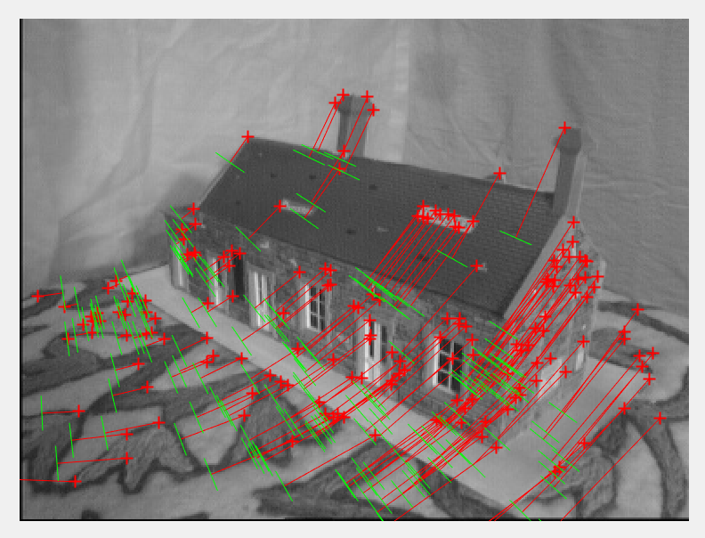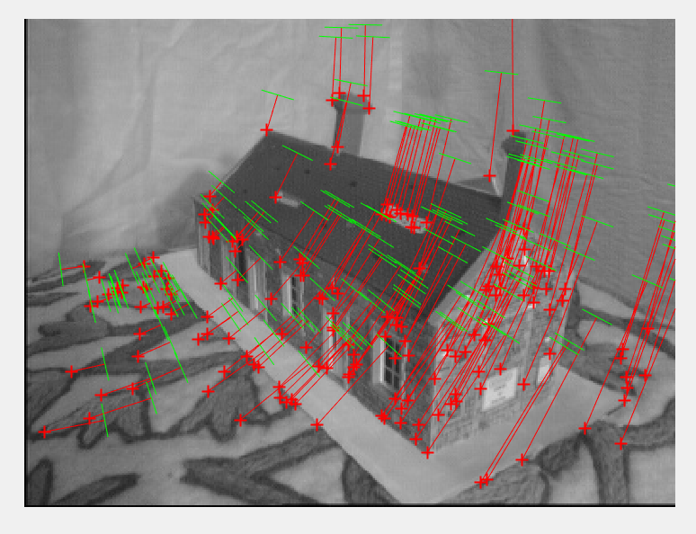

Figure: Normalized algorithm with ground truth matches for house

Average Residual for image 1: 3.0116e+03

Average Residual for image 2: 3.4863e+03

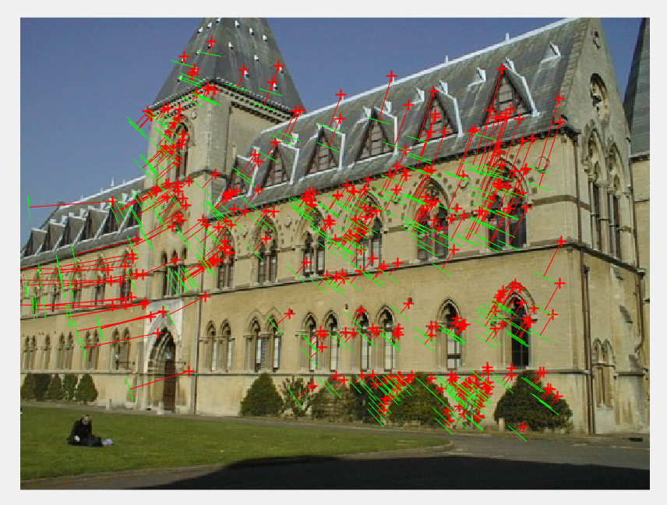 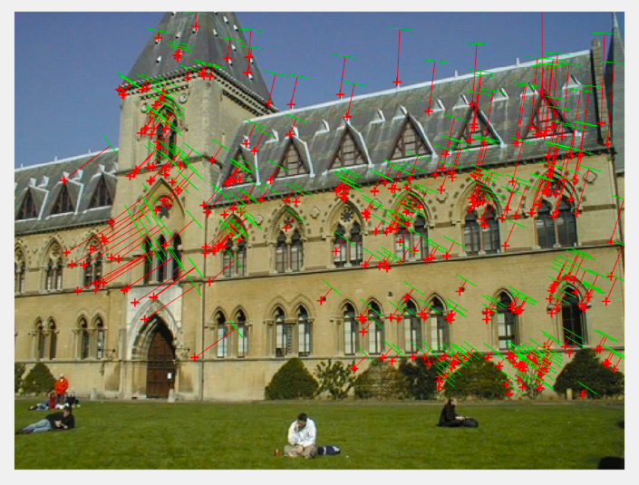

Figure: Normalized algorithm with ground truth matches for library

Average Residual for image 1: 724.3724

Average Residual for image 2: 743.6100

**Using putative matches and RANSAC**

We can obtain the matches using RANSAC. In RANSAC, we take random 8 points from both of the images and fit the fundamental matrix into it. We run this process a number of times and take the matrix that resulted in the highest number of inliers.

The inliers can be calculated by thresholding the result obtained by calculating x*F*x’. Generally,

x*F*x’ = 0.

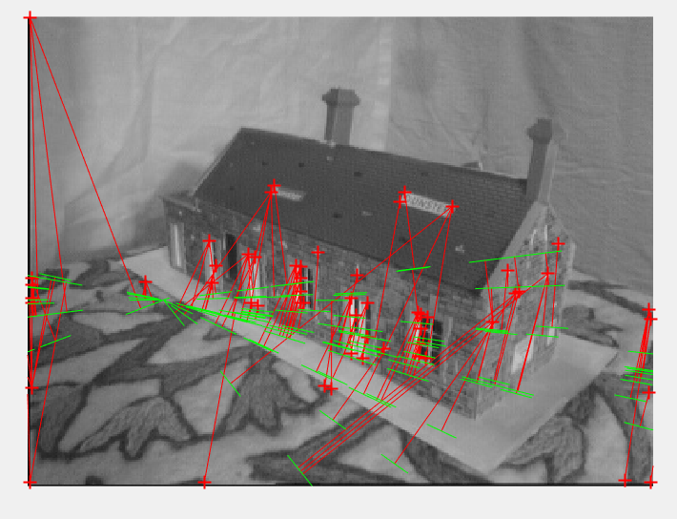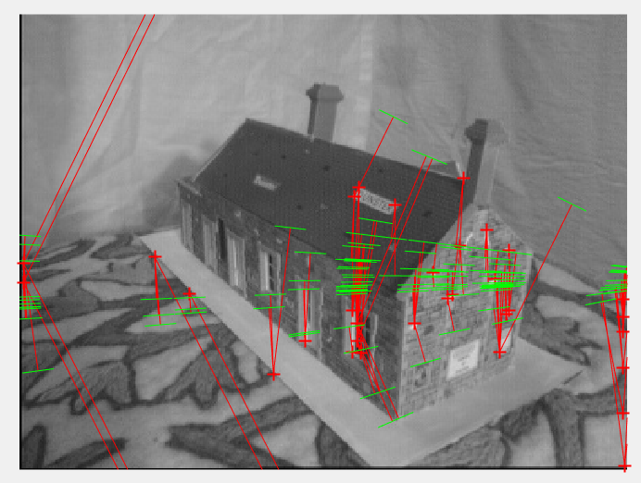

Figure: Using RANSAC for house

Number of inliers = 149 (out of 200)

Average Residual for image 1: 3.2478e+03

Average Residual for image 2: 3.0571e+03

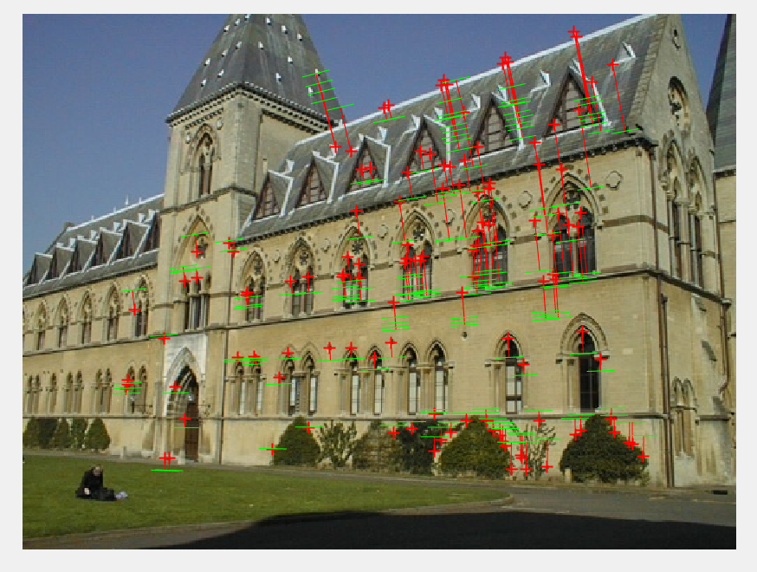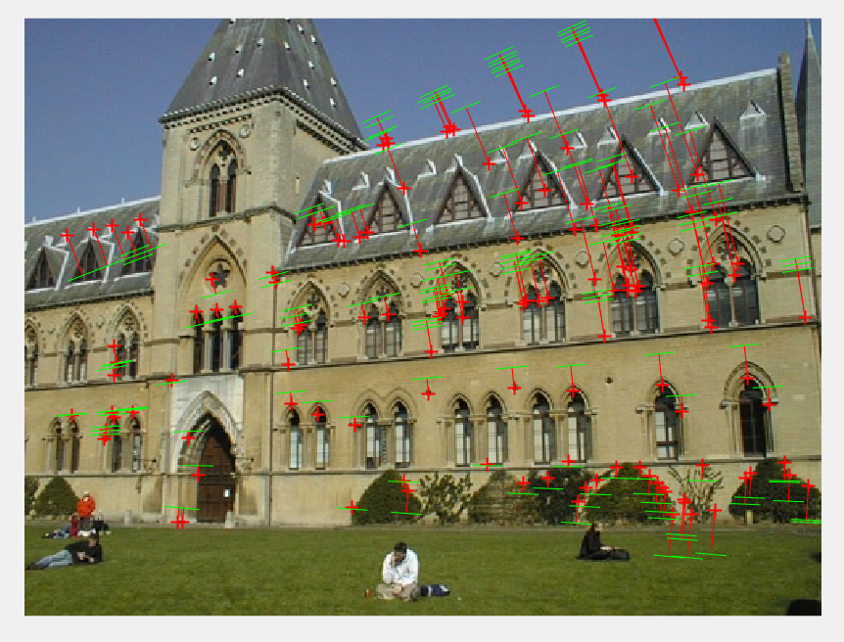Figure: Using RANSAC for Library

Number of inliers = 173 (out of 200)

Average Residual for image 1: 791.5242

Average Residual for image 2: 738.2826

**Comparison between the quality of matches obtained by RANSAC with the ground truth matches:**

The result obtained from RANSAC are equivalent to the results obtained from the ground truth matches in terms of the average residuals for the image. However, if we look into the epipolar lines, the results for ground truth matches are much better.

Also, for the image of the library the results using RANSAC are much better as compared to that for the house image. This is because, I am using Harris corner detector, which is not very efficient if similar kind of features are present in an image for more than one time. This happens in the case of the image of house.

**Triangulation**

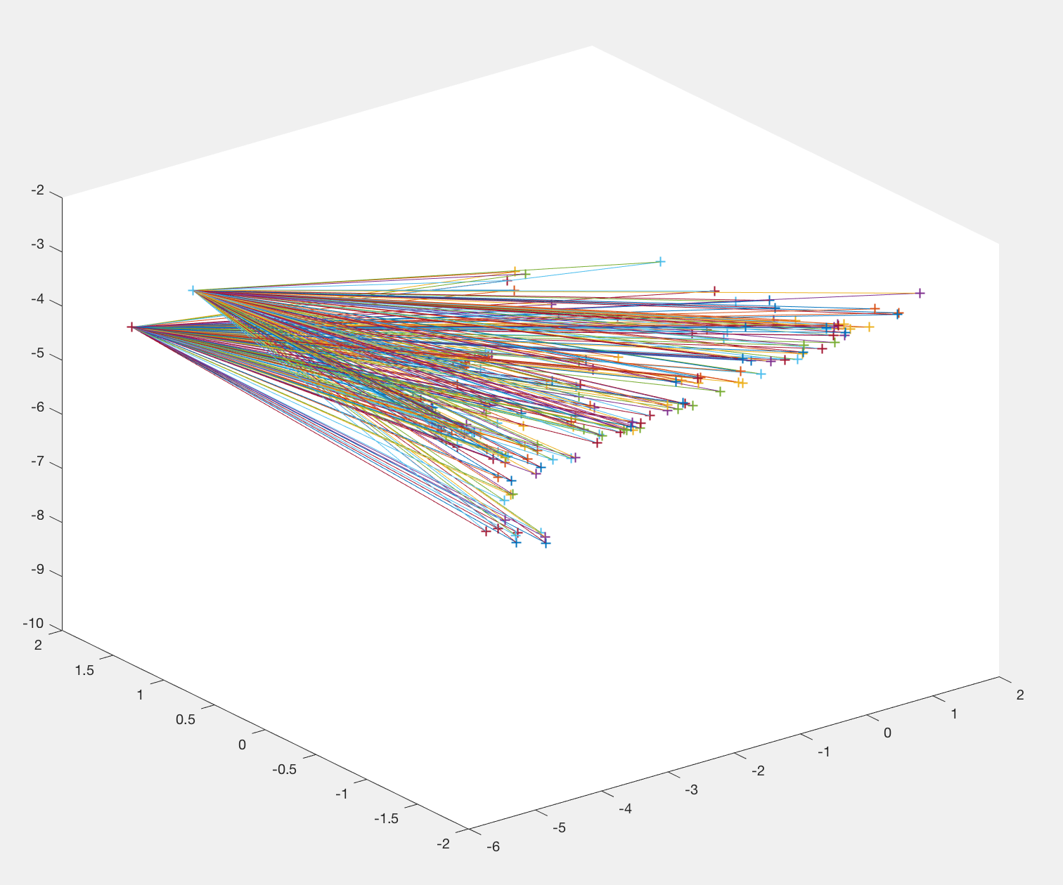

Figure: Triangulation of the 2 camera centers and the 3D points for House

Camera Center 1: [ -4.8225, 1.4807, -3.6490]

Camera Center 2: [ -5.0495, 1.9317, -4.6628]

Average residual for house image 1 points and 3D points: 8.3508e+04

Average residual for house image 2 points and 3D points: 7.6965e+04

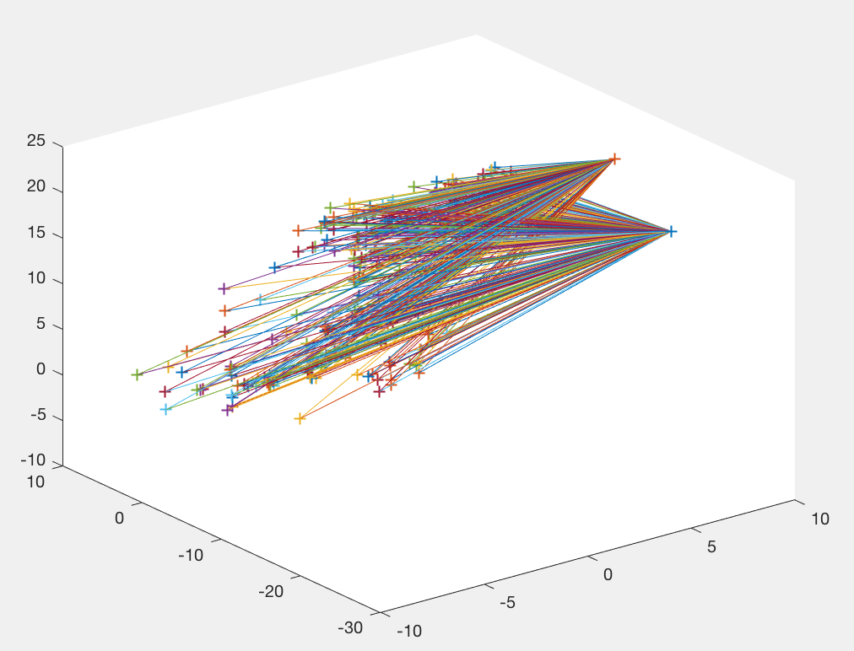

Figure: Triangulation of the 2 camera centers and the 3D points for Library

Camera Center 1: [7.2886, -21.5212, 17.7350]

Camera Center 2: [6.8941, -15.3923 ,23.4150]

Average residual for library image 1 points and 3D points: 1.5160e+05

Average residual for library image 2 points and 3D points: 1.2388e+05

# Conclusion:

The normalized method for estimating fundamental matrix is better than the unnormalised method since it is immune to the noise. RANSAC is an efficient method to calculate homography and fundamental matrix. In this project, we gained knowledge about feature detector, homography, camera matrix, fundamental matrix, triangulation etc.

# References:

* <https://www.robots.ox.ac.uk/~vgg/hzbook/hzbook2/HZepipolar.pdf>
* <https://ublearns.buffalo.edu/bbcswebdav/pid-4302481-dt-content-rid-16661646_1/courses/2179_10783_PsC/lecture-20171002-hw2-geometric-camera.pdf>